NETFLIX MARKETING INFORMATION SYSTEM

A PAPER SUBMITTED TO THE FACULTY

COLLEGE OF COMPUTING AND INFORMATION TECHNOLOGIES

IN PARTIAL FULFILLMENT OF THE REQUIREMENTS

FOR THE DEGREE OF

BACHELOR OF SCIENCE IN COMPUTER SCIENCE

Presented By:

ROVIC MATHEW BAGADIONG

JOHN ANDREW DIVINA

LYLE MARIE NALANGAN

Submitted To:

ARMIDA P. SALAZAR

TABLE OF CONTENTS

**PAGE**

TITLE PAGE i

TABLE OF CONTENTS ii

LIST OF FIGURES iii

1. INTRODUCTION 1
2. SYSTEM DESIGN 4
3. USER INTERFACE DESIGN 7
4. IMPLEMENTATION 10
5. CONCLUSION 21

**LIST OF FIGURES**

PAGE

Figure 1: Entity Relationship Diagram (ERD) for Netflix 4

Figure 2: Wireframe Design for the Login Page 7

Figure 3: Wireframe Design for the Insights Page 7

Figure 4: Wireframe Design for the Transaction Page 8

Figure 5: Mockup Design for the Login Page 8

Figure 6: Mockup Design for the Insights Page 9

Figure 7: Mockup Design for the Transaction Page 9

Figure 8: Table Structure of Campaign 18

Figure 9: Table Structure of Plan 18

Figure 10: Table Structure of Platform 18

Figure 11: Table Structure of Sales Data 18

Figure 12: Table Structure of Social Media Engagement 19

Figure 13: Table Structure of Website Traffic 19

Figure14: Sample Data for Netflix MIS 19

# Introduction

## Project Overview

Netflix, founded in 1997, Netflix offers a vast library of movies, TV shows, and original content through a subscription-based model. It has revolutionized the entertainment industry with its innovative approach to content delivery and personalized recommendations. It is a global leader in streaming entertainment, aims to enhance its marketing capabilities by developing a comprehensive Marketing Information System (MIS). Amid increasing inflation and heightened competition in the streaming industry, Netflix experienced a significant drop in subscribers, losing millions over the course of less than a year. This decline underscores a critical challenge in their marketing information system, highlighting the need for improved data insights and adaptive marketing strategies to better understand and react to rapidly changing consumer behaviors and market conditions.

## Objectives of the Study

The general objective of this study is to develop a comprehensive Marketing Information System (MIS) for Netflix that enhances its ability to regain, retain, and acquire subscribers through effective data analysis and innovative marketing strategies. This system aims to leverage advanced technologies to provide actionable insights and optimize marketing efforts, ultimately improving subscriber engagement and satisfaction. The specific objectives are as follows:

1. Analyze User Data and Behavior; This objective focuses on understanding how Netflix collects, processes, and utilizes user data within its marketing information system. By studying patterns and trends in user behavior, the goal is to uncover insights that can lead to more effective targeted marketing efforts and personalized content recommendations.
2. Examine the Role of Technology and Innovation; This objective involves exploring the integration of advanced technologies such as AI, machine learning, and big data analytics into Netflix’s marketing information system. The study aims to evaluate how these technologies enhance the precision and efficiency of Netflix’s marketing strategies, contributing to better decision-making and strategic outcomes.
3. Optimize Marketing Campaign; This objective is to identify opportunities for optimizing Netflix’s marketing campaigns to achieve a better Return on Investment (ROI). This includes analyzing current campaign performance, recommending improvements in campaign design, targeting specific audience segments, refining timing strategies, and optimizing overall campaign execution.

These objectives collectively aim to enhance Netflix’s marketing capabilities by leveraging data-driven insights, innovative technologies, and strategic optimizations to attract, retain, and engage subscribers effectively in a competitive streaming industry landscape.

## Scope and Limitation

The scope of this system is focused on providing a solution to regain, retain, and acquire Netflix subscribers through data analyzation. This involves utilizing data to gain insights into subscriber behavior, predict churn, and develop targeted marketing strategies. The system aims to enhance subscriber engagement and satisfaction by leveraging data-driven approaches to optimize marketing efforts and content recommendations.

This system is limited only to analyzing required data to provide a better marketing strategy and will not interfere with other operations within the company.

## Technologies Used

The system utilizes a combination of hardware and software technologies to achieve its objectives. On the hardware side, it employs laptops and computers for data analysis, processing, and storage. For software, Eclipse is used as the integrated development environment for writing and testing code. MySQL Workbench is used for managing and interacting with the database, facilitating the organization and retrieval of subscriber data. Canva is used for creating visual content and marketing materials, aiding in the development of effective marketing strategies based on the data insights generated by the system

# SYSTEM DESIGN

## A black background with white circles Description automatically generatedER Diagram (Entity-Relationship Diagram)

**Figure 1:** *Entity Relationship Diagram (ERD) for Netflix*

The Entity Relationship Diagram (ERD) for Netflix illustrates the relationships between various entities involved in managing website traffic, social media engagement, customer feedback, sales data, conversion rates, and promotion costs.

**Entities and Attributes:**

1. **Website Traffic**

* Attributes: traffic_id, traffic_date, traffic_views, campaign_id, unique_visitors, traffic_source

1. **Campaign**

* Attributes: campaign_id, campaign_name, campaign_startdate, campaign_budget, campaign_enddate, campaign_objective

1. **Social Media Engagement**

* Attributes: engagement_id, engagement_date, engagement_platform, campaign_id, engagement_likes, engagement_shares, engagement_comments

1. **Customer Feedback**

* Attributes: feedback_id, feedback_date, feedback_rating, feedback_comment, campaign_id, customer_id

1. **Sales Data**

* Attributes: sales_id, sales_date, sale_amount, campaign_id, plan_id

1. **Conversion Rates**

* Attributes: conversion_id, conversion_date, campaign_id, plan_id

1. **Promotion Cost**

* Attributes: cost_id, cost_date, campaign_id, cost_amount

## Schema Design

The schema design for Netflix encompasses several key entities that reflect its campaign management, sales, and engagement tracking. This design ensures a comprehensive view of marketing efforts, customer interaction, and sales performance across different platforms and plans.

campaign (campaign_id, campaign_name,  
 campaign_startdate, campaign_enddate, campaign_cost,   
 campaign_type),

plan (plan_id, plan_name, plan_cost),

platform (platform_id, platform_name),

sales_data (sales_id, sales_date, sales_amount, plan_id, campaign_id),

social_media_engagement (engagement_id, engagement_date, platform_id,   
campaign_id, engagement_likes, engagement_comments, engagement_shares),

website_traffic (traffic_id, traffic_date, campaign_id, platform_id)

## Normalization

Normalization is a crucial technique used in all databases. Our database has been normalized to ensure proper data organization, integrity, and rigidity.

**Campaign**: campaign have campaign_id which is then used in multiple tables (sales_data, social_media_engagement, and website_traffic) to eliminate data redundancy.

**Plan**: plan have plan_id which is used in sales_data to identify the plan_name and plan_cost for certain sales.

**Platform**: plan have platform_id which is used for social_media_engagement to identify which platform did a certain engagement came from.

# USER INTERFACE DESIGN

## Wireframes

**Figure 2:** *Wireframe Design for the Login Page*

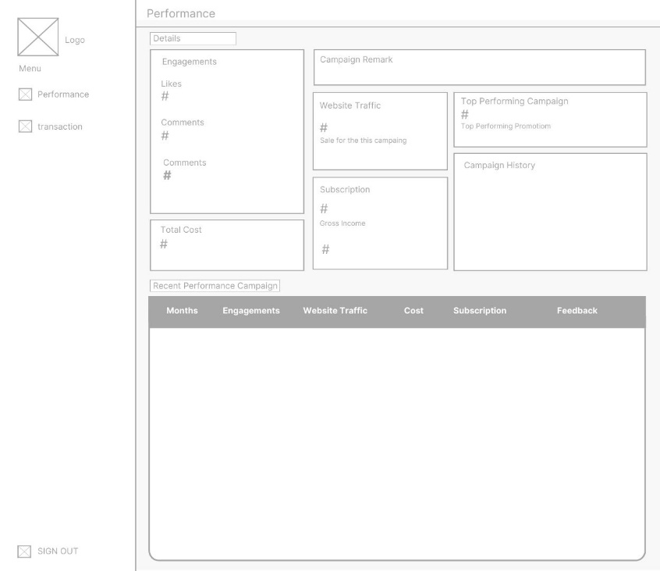

## 

**Figure 3:** *Wireframe Design for the Insights Page*

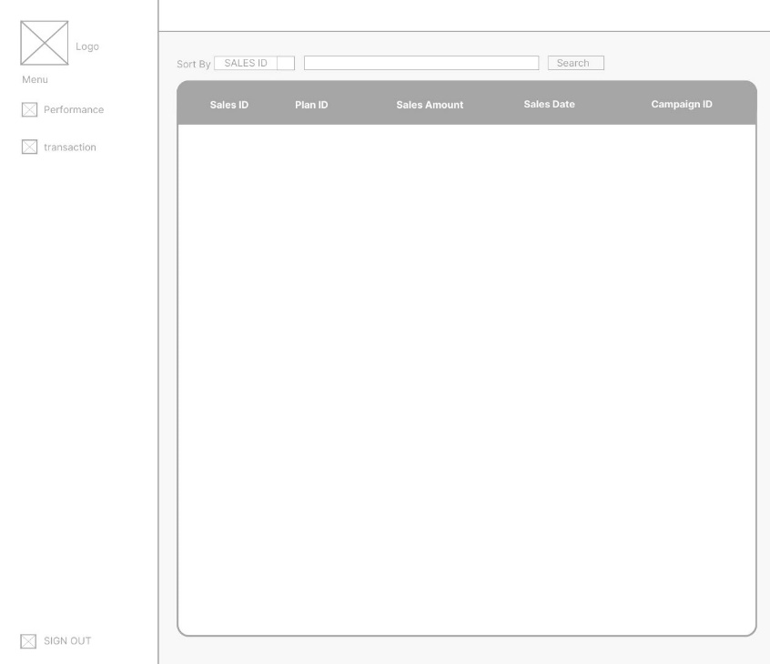

**Figure 4:** *Wireframe Design for the Transaction Page*

## Mockups

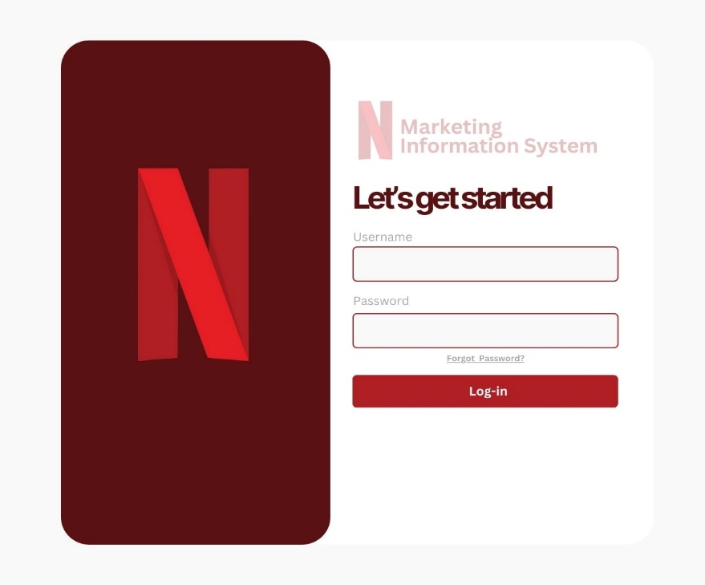

**Figure 5:** *Mockup Design for the Login Page*

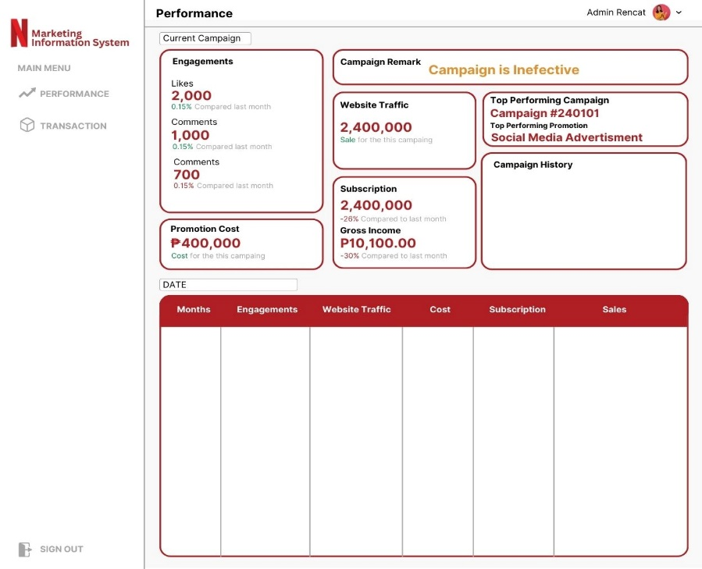

**Figure 6:** *Mockup Design for the Insights Page*

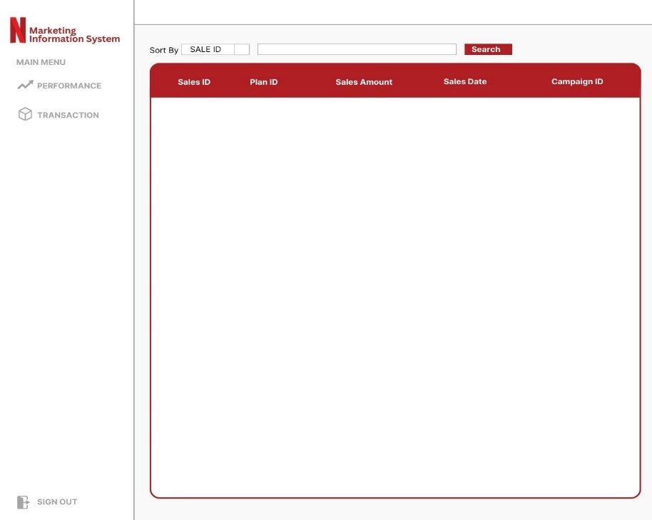

**Figure 7:** *Mockup Design for the Transaction Page*

# IMPLEMENTATION

## Database Creation

## Sql Scripts

To summarize each campaign:

To load the table:

To sort the table:

**Table Structures**

The figures below depict the table structures in MySQL, illustrating how data is organized and stored within a relational database system. Each figure represents one or more tables, visually outlining the columns (fields) and rows (records) that collectively define and store data related to specific entities or concepts.

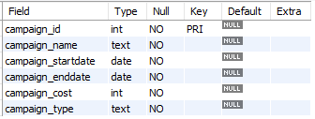

## Figure 8: Table Structure of Campaign

## 

## Figure 9: Table Structure of Plan

## 

## Figure 10: Table Structure of Platform

## Figure 11: Table Structure of Sales Data

## 

## Figure 12: Table Structure of Social Media Engagement

## 

## Figure 13: Website Traffic

## Data Insertion

## Sample Data

**Figure 14:** *Sample Data for Netflix MIS*

## Application Development

## Frontend

The application front-end was first developed and designed in Canva. This initial design phase allowed for the creation of a visual mockup that guided the development process. Once the mockup was finished, it was implemented in Eclipse IDE using Java Swing.

## Backend

The application back-end was developed using Eclipse IDE, leveraging its powerful development tools and integration capabilities.

# Conclusion

## Summary of Work Done

The project involved the development of a comprehensive Marketing Information System (MIS) for Netflix, aiming to enhance its marketing capabilities through data-driven insights and advanced technologies. Key steps included:

**Database Design and Normalization:** The database was designed to include several key entities such as campaigns, plans, platforms, sales data, social media engagement, and website traffic. Normalization was applied to ensure data integrity and eliminate redundancy.

**User Interface Design:** Wireframes and mockups for the application's login, insights, and transaction pages were created to guide the development process. The frontend was initially designed in Canva and then implemented using Java Swing in Eclipse IDE.

**Backend Development:** The backend was also developed using Eclipse IDE, integrating various components to manage and process data effectively.

Implementation of SQL Scripts: SQL scripts were written to manage campaign history, load tables, and sort data efficiently.

## Challenges Faced

Several challenges were encountered during the development of the Netflix Marketing Information System:

**Data Integration:** Integrating various data sources to provide a cohesive view of marketing efforts required significant effort in data cleaning and transformation.

**Technology Integration:** Ensuring seamless integration of advanced technologies like AI and machine learning for data analysis and insights posed technical difficulties.

**System Performance:** Optimizing the performance of the database and application to handle large volumes of data without lag was challenging.

## Lessons Learned

The project provided several key lessons:

**Importance of Normalization:** Proper database normalization is crucial for maintaining data integrity and improving query performance.

**Effective UI/UX Design:** Creating detailed wireframes and mockups before development helps in building a user-friendly interface and smooth development process.

**Integration of Advanced Technologies:** Incorporating AI and machine learning can significantly enhance data analysis capabilities and provide deeper insights into user behavior and marketing effectiveness.

## Future Enhancements

Future enhancements could focus on:

**Scalability:** Improving the system's scalability to handle even larger datasets as Netflix grows and its data collection expands.

**Advanced Analytics:** Further integrating advanced analytics and machine learning models to predict user behavior and optimize marketing strategies more effectively.

**User Personalization:** Enhancing personalization features to tailor content and marketing efforts more precisely to individual user preferences and behaviors.

**Real-time Data Processing:** Implementing real-time data processing capabilities to provide up-to-date insights and enable immediate marketing adjustments.